L systems reflection

[] = execute new branch (open bracket start, closed bracket end)

+ = turn right

- = turn left

F = line segment

A = defines new rule

|, & = logical operators

~(a) = pitch, roll, turn random value up to a degrees (default 180)

Documentation:

[L-System (sidefx.com)](https://www.sidefx.com/docs/houdini/nodes/sop/lsystem.html)

Default angle is 28 degrees.

Steven’s curved trees example:

Premise: FFA

Rule 1: A = F+F[+F]A

In rule 1 we define it recursively, terminating at # generations.

Cool things:

MATH FUNCTIONS! Put math functions in attribute editor! (first link)

Output connected to revolve node!



Side project: Design birch trees with rules from scratch

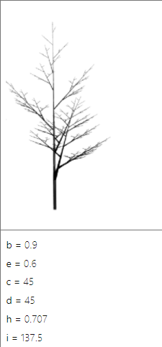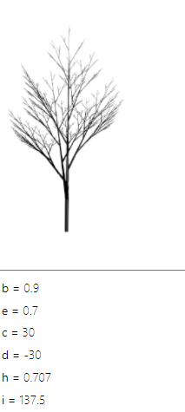

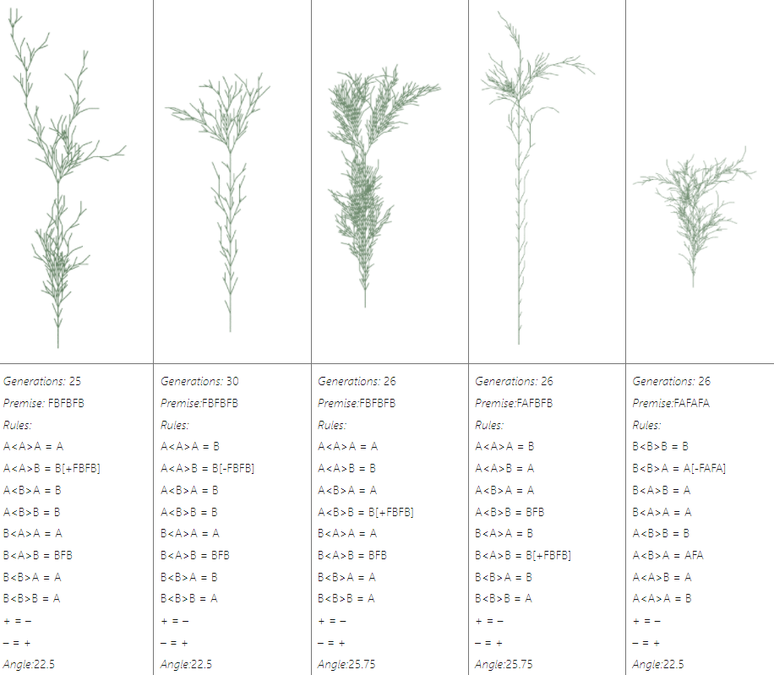

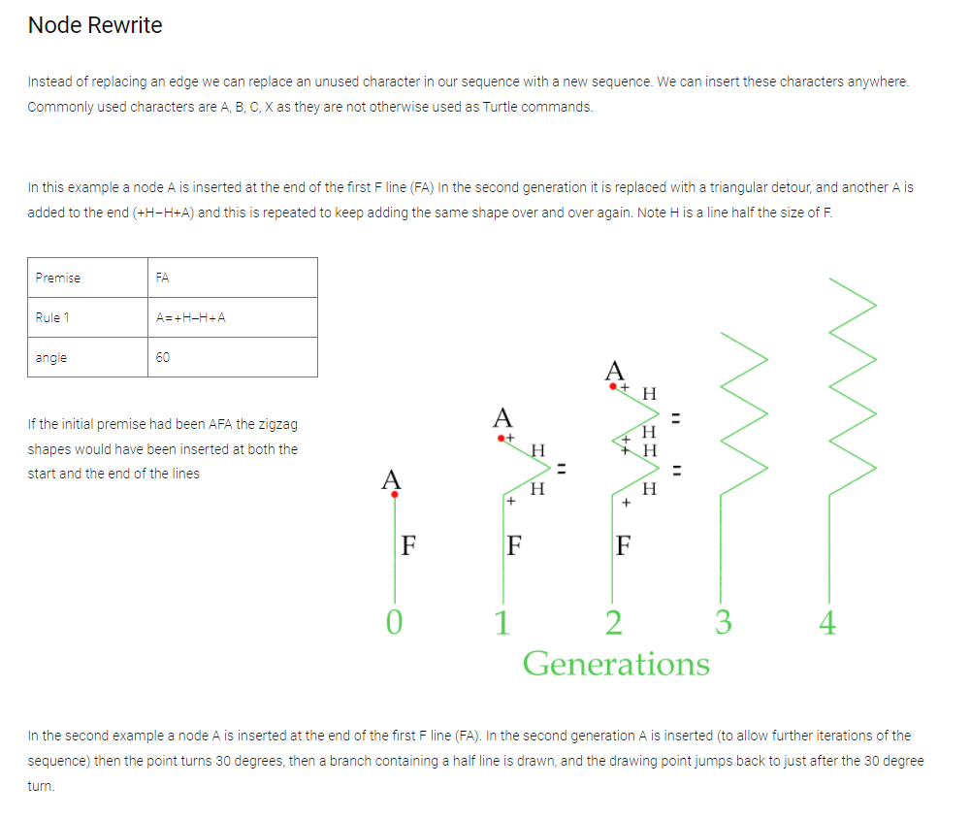

Incorrect Rule 1 (--, not –). Play with the angle slider monotonically without changing sign. Cool unfurl effect.

Motivation:

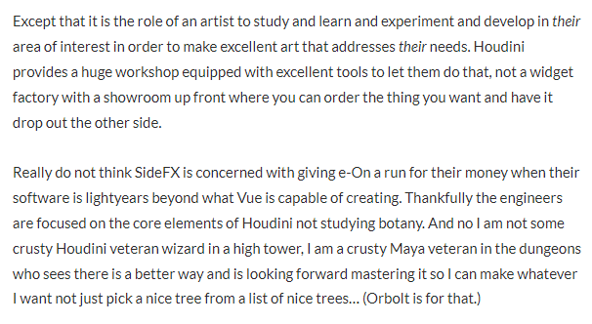

FAQs that I will probably have:

Resolution of mesh too low? Is it patchy and bad? **Raise it with rows and columns parameter.**